` Syllabus
UDSC – 301 Statistics for Data Science
(Batch 2024 – 2025)
Unit – I |  | Point Estimation
 | Sampling Distributions and the Central Limit Theorem | 7.2
 | Point Estimation: Unbiased Estimators | 7.3.1
 | Variance of a Point Estimator | 7.3.2
 | Mean squared Error of an Estimator | 7.3.5
 | Methods of Point Estimation:
 | Method of Moments | 7.4.1
 | Maximum Likelihood Estimators | 7.4.2
 | Bayesian Estimation of Parameters | 7.4.3
Unit – II | Interval Estimation for a Single Sample
 | Confidence Intervals on mean of a Normal Distribution | 8.2
 | Confidence Interval on variance of a Normal Distribution | 8.3
 | Large Sample Confidence Interval for a Population Proportion | 8.4
 | Bootstrap Confidence Interval | 8.6
 | Tolerance and Prediction Intervals | 8.7

Key Text : Montgomery Douglas C., Runger George C., Applied Statistics and Probability for
Engineers, Seventh Edition, Wiley, 2018
Chapters: 7 -9 (up to 9.8), 10, 11

7th chpater
7-3. PVC pipe is manufactured with a mean diameter of 1.01 inch and a standard deviation of 0.003 inch. Find the probability that a random sample of n = 9 sections of pipe will have a sample mean diameter greater than 1.009 inch and less than 1.012 inch

Problem: Find the probability that the average diameter of 9 randomly selected PVC pipes is between 1.009 and 1.012 inches, given the population mean is 1.01 inches and the standard deviation is 0.003 inches.
Solution:
- Calculate Standard Error: Standard Error (SE) = Standard Deviation / sqrt(sample size) = 0.003 / sqrt(9) = 0.001.
- Calculate Z-scores:
  - Z1 = (1.009 - 1.01) / SE = -1
  - Z2 = (1.012 - 1.01) / SE = 2
- Find Probabilities: Use a Z-table or calculator to find the area under the standard normal curve between Z1 and Z2.
- Result: The probability is approximately 0.8185 or 81.85%.
Interpretation: There's an 81.85% chance that the average diameter of 9 randomly selected pipes falls between 1.009 and 1.012 inches
7-5. A synthetic iber used in manufacturing carpet has tensile strength that is normally distributed with mean 75.5 psi and standard deviation 3.5 psi. Find the probability that a random sample of n = 6 iber specimens will have sample mean tensile strength that exceeds 75.75 psi.

Problem: Find the probability that the average tensile strength of 6 randomly selected fiber specimens exceeds 75.75 psi, given the population mean is 75.5 psi and standard deviation is 3.5 psi.
Solution:
- Identify distribution: Sample mean follows a normal distribution due to the Central Limit Theorem.
- Calculate standard error: Standard error (SE) = population standard deviation / sqrt(sample size) = 3.5 / sqrt(6) ≈ 1.436.
- Standardize: Calculate z-score = (sample mean - population mean) / SE = (75.75 - 75.5) / 1.436 ≈ 0.174.
- Find probability: Use z-table or calculator to find P(Z > 0.174) ≈ 0.4325.
Answer: The probability of the sample mean exceeding 75.75 psi is approximately 43.25%.

9th chapter

9-1. State whether each of the following situations is a correctly stated hypothesis testing problem and why.
(a) H H 0 1 : ,: μ = 25 25 μ ≠ (b) H H 0 1 :> , : σ σ 10 10 = (c) Hx Hx 0 1 : ,: = ≠ 50 50 (d) Hp Hp 0 1 : ,: = . = . 01 05 (e) H H 0 1 : : = s s 30 30

Key Points for Correct Hypothesis Testing
- Two Hypotheses: There must be a null hypothesis (H₀) and an alternative hypothesis (H₁).
- Clear Parameters: The hypotheses must clearly specify the parameter being tested (e.g., μ for population mean, σ for population standard deviation).
- Equality in Null: The null hypothesis typically states that the parameter equals a specific value.
- Contradiction in Alternative: The alternative hypothesis contradicts the null. It can be one-tailed (>, <) or two-tailed (≠).

Evaluating Each Hypothesis Pair

(a) H₀: μ = 25, H₁: μ ≠ 25
- Correct: This is a correctly stated hypothesis test for the population mean (μ).

(b) H₀: σ > 10, H₁: σ = 10
- Incorrect: The null hypothesis should contain equality. It should be H₀: σ = 10.

(c) Hx₀: x̄ = 50, Hx₁: x̄ ≠ 50
- Incorrect: x̄ represents the sample mean, not the population parameter. The hypotheses should be about μ.

(d) Hp₀: p = 0.1, Hp₁: p = 0.5
- Incorrect: The alternative hypothesis should not specify a specific value. It should be p ≠ 0.1 or p > 0.1 or p < 0.1.

(e) H₀: s = 30, H₁: s = 30
- Incorrect: Both hypotheses are identical. There's no comparison to make.

Summary
Only hypothesis pair (a) is correctly stated for a hypothesis test. The others have issues with the parameters used, the equality in the null hypothesis, or the contradiction in the alternative hypothesis.

9-3. The standard deviation of critical dimension thickness in semiconductor manufacturing is σ = 20 nm. (a) State the null and alternative hypotheses used to demonstrate that the standard deviation is reduced.

(b) Assume that the previous test does not reject the null hypothesis. Does this result provide strong evidence that the standard deviation has not been reduced? Explain.

Part (a)
- Goal: Show standard deviation has reduced from σ = 20 nm.
- Null hypothesis (H₀): σ = 20 nm (standard deviation is unchanged)
- Alternative hypothesis (H₁): σ < 20 nm (standard deviation is reduced)

Part (b)
- Result: Null hypothesis not rejected.
- Conclusion: No strong evidence to say standard deviation has reduced.
- Reason: Failing to reject H₀ doesn't mean it's true, only that data doesn't strongly support H₁.
Answer:
- (a) Null hypothesis (H0): Standard deviation (σ) = 20 nm.
  - Alternative hypothesis (H1): Standard deviation (σ) < 20 nm.
- (b) Not rejecting null hypothesis does not mean standard deviation hasn't been reduced.
  - It only means there's insufficient evidence to conclude the reduction.
  - It could be due to small sample size or low statistical power.
  - Further investigation or larger sample size might be needed.

9-5. A textile iber manufacturer is investigating a new drapery yarn, which the company claims has a mean thread elongation of 12 kilograms with a standard deviation of 0.5 kilograms. The company wishes to test the hypothesis H0 :μ = 12 against H1 :< , μ 12 using a random sample of four specimens.

(a) What is the type I error probability if the critical region is deined as x < 11 5. kilograms?

(b) Find β for the case in which the true mean elongation is 11.25 kilograms.

(c) Find β for the case in which the true mean is 11.5 kilograms.

Understanding the Problem
- Hypothesis Testing: The company wants to test if the mean thread elongation (μ) is less than 12 kg.
- Null Hypothesis (H0): μ = 12 kg (mean elongation is 12 kg)
- Alternative Hypothesis (H1): μ < 12 kg (mean elongation is less than 12 kg)
- Sample Size: n = 4
- Population Standard Deviation: σ = 0.5 kg
- Critical Region: x̄ < 11.5 kg (reject H0 if sample mean is less than 11.5 kg)

Solving the Problem

(a) Type I Error Probability (α)
- Type I Error: Rejecting H0 when it's true.
- Calculate the probability of x̄ < 11.5 kg when μ = 12 kg.
- Use the Z-score formula: Z = (x̄ - μ) / (σ / √n)
- Find the corresponding probability from the Z-table.

(b) β for μ = 11.25 kg
- Type II Error (β): Failing to reject H0 when it's false.
- Calculate the probability of x̄ >= 11.5 kg when μ = 11.25 kg.
- Use the Z-score formula with μ = 11.25 kg.
- Find the corresponding probability from the Z-table.

(c) β for μ = 11.5 kg
- Similar to part (b), but use μ = 11.5 kg in the Z-score formula.
Note: To provide specific numerical answers, you'll need to calculate the Z-scores and look up the corresponding probabilities in a Z-table.
9-7. In Exercise 9-5, in the boundary of the critical region if the type I error probability is (a) α = 0.01 and n = 4 (c) α = 0.01 and n = 16 (b) α = 0.05 and n = 4 (d) α = 0.05 and n = 16
Understanding the Problem:
- We're dealing with a hypothesis test for a single sample.
- We need to find the critical region boundary.
- This boundary depends on the Type I error rate (α) and sample size (n).
Solution Approach:
- Identify the test statistic: Based on the information given in Exercise 9-5 (which is not provided here), determine the appropriate test statistic (e.g., z, t).
- Determine the distribution: Identify the distribution of the test statistic under the null hypothesis (e.g., standard normal, t-distribution).
- Find the critical value: Use the given α and n to find the critical value from the corresponding distribution table. This value is the boundary of the critical region.
Specific Calculations:
You'll need the exact details of Exercise 9-5 to perform the calculations. However, the general steps outlined above will guide you.
Example (Assuming a z-test):
If the test statistic is z and we're using a z-table:
- For α = 0.01 and a two-tailed test, the critical values are approximately ±2.58.
- For α = 0.05 and a two-tailed test, the critical values are approximately ±1.96.
The sample size (n) would affect the calculation if a t-test is used, as the degrees of freedom would change.
Note: The critical region is the range of values for the test statistic that leads to rejecting the null hypothesis.
9-9. In Exercise 9-5, calculate the P-value if the observed statistic is (a) x = 11.25 (b) x = 11.0 (c) x = 11.75
Understanding the Problem:
- We're dealing with a hypothesis test for a single sample.
- We need to find the P-value for different observed statistics (x).
- The necessary information to solve this is likely provided in Exercise 9-5 (sample size, population mean, standard deviation, and hypothesis).
Steps to Solve:
- Refer to Exercise 9-5: Gather the required information (n, μ, σ, H₀, H₁) from this exercise.
- Calculate the test statistic: Use the formula for the z-test statistic: z = (x̄ - μ) / (σ / √n).
- Determine the P-value:
  - For a one-tailed test, find the area under the standard normal curve to the right (or left) of the calculated z-value.
  - For a two-tailed test, find the combined area in both tails.
- Interpret the P-value: Compare the P-value to the significance level (α) to make a decision about the null hypothesis.
Note: Without the specific details from Exercise 9-5, I cannot provide numerical answers.
Example (Hypothetical):
If Exercise 9-5 provided n = 25, μ = 10, σ = 2, and H₀: μ = 10, H₁: μ > 10, then:
- For x = 11.25, z = (11.25 - 10) / (2 / √25) = 1.25.
- Find the area to the right of z = 1.25 in the z-table to get the P-value.
Repeat steps 2 and 3 for x = 11.0 and x = 11.75.
Remember: The specific calculations will depend on the information given in Exercise 9-5.

Understanding the Problem
- Product: New shampoo
- Interest: Foam height (normally distributed, σ = 20 mm)
- Hypothesis: H₀: μ = 175 mm vs H₁: μ > 175 mm (one-tailed test)
- Sample size: n = 10

Solving the Problem

(a) Type I Error Probability (α)
- Critical region: x > 185
- Calculate z-score: z = (185 - 175) / (20/√10) ≈ 1.58
- Find α: P(Z > 1.58) from z-table ≈ 0.0571

(b) Type II Error Probability (β) when μ = 185
- Calculate z-score: z = (185 - 185) / (20/√10) = 0
- Find β: P(Z < 1.58) = 1 - P(Z > 1.58) ≈ 0.9429

(c) Type II Error Probability (β) when μ = 195
- Calculate z-score: z = (185 - 195) / (20/√10) ≈ -1.58
- Find β: P(Z < -1.58) ≈ 0.0571

Summary
- α: Probability of rejecting H₀ when it's true ≈ 0.0571
- β when μ = 185: Probability of accepting H₀ when it's false (μ = 185) ≈ 0.9429
- β when μ = 195: Probability of accepting H₀ when it's false (μ = 195) ≈ 0.0571

9-25. The proportion of adults living in Tempe, Arizona, who
are college graduates is estimated to be p = 0.4. To test this
hypothesis, a random sample of 15 Tempe adults is selected. If
the number of college graduates is between 4 and 8, the hypothesis will be accepted; otherwise, you will conclude that p ≠ . 0 4.
(a) Find the type I error probability for this procedure, assuming that p = 0.4.
(b) Find the probability of committing a type II error if the true
proportion is really p = 0.2.

Problem:
- Estimating the proportion of college graduates in Tempe, AZ.
- Hypothesized proportion (p) = 0.4.
- Sample size (n) = 15.
- Decision rule: Accept p = 0.4 if number of graduates is between 4 and 8.
Tasks:
- Calculate Type I error probability (α) assuming p = 0.4.
- Calculate Type II error probability (β) assuming true p = 0.2.

Solution

(a) Type I Error Probability (α)
- Type I error: Rejecting a true null hypothesis.
- Calculate probability of getting less than 4 or more than 8 graduates assuming p = 0.4.
- Use binomial distribution with n = 15 and p = 0.4.
- Sum probabilities for X < 4 and X > 8.

(b) Type II Error Probability (β)
- Type II error: Failing to reject a false null hypothesis.
- Calculate probability of getting between 4 and 8 graduates assuming true p = 0.2.
- Use binomial distribution with n = 15 and p = 0.2.
- Sum probabilities for 4 ≤ X ≤ 8.
- β is the complement of this probability.
Note: Calculations involve summing binomial probabilities, which can be tedious. Statistical software or tables can simplify the process.

9-1 Hypothesis Testing
Hypothesis Testing is a statistical method used to make decisions or inferences about population parameters based on sample data. The process involves making a conjecture (hypothesis) and then determining whether the data supports or refutes this conjecture.

9-1.1 Statistical Hypotheses
A statistical hypothesis is a statement or claim about a population parameter (such as a mean, proportion, or variance). There are two types of hypotheses:
- Null Hypothesis (H0H_0H0​): This is the default or initial assumption. It usually states that there is no effect or no difference, meaning the parameter is equal to a specific value.
  - Example: H0:μ=100H_0: \mu = 100H0​:μ=100, where μ\muμ is the population mean.
- Alternative Hypothesis (H1H_1H1​ or HaH_aHa​): This is a statement that contradicts the null hypothesis. It represents what we want to test or believe is true.
  - Example: H1:μ≠100H_1: \mu \neq 100H1​:μ=100 (two-sided) or H1:μ>100H_1: \mu > 100H1​:μ>100 (one-sided).

9-1.2 Tests of Statistical Hypotheses
Tests of Statistical Hypotheses involve using sample data to decide whether to reject the null hypothesis in favor of the alternative hypothesis. This decision is based on the likelihood of observing the sample data if the null hypothesis were true.
Key elements:
- Test Statistic: A function of the sample data that provides a basis for deciding whether to reject H0H_0H0​. Common test statistics include the t-statistic, z-statistic, and chi-square statistic.
- Rejection Region: A range of values for the test statistic that leads to the rejection of H0H_0H0​. This region is determined by the significance level α\alphaα (usually 0.05, 0.01, etc.).

9-1.3 One-Sided and Two-Sided Hypotheses
One-sided hypotheses are those where the alternative hypothesis specifies a direction (greater than or less than):
- Example: H1:μ>100H_1: \mu > 100H1​:μ>100 (right-tailed) or H1:μ<100H_1: \mu < 100H1​:μ<100 (left-tailed).
Two-sided hypotheses do not specify a direction and instead test for any difference:
- Example: H1:μ≠100H_1: \mu \neq 100H1​:μ=100.

9-1.4 P-Values in Hypothesis Tests
P-value is the probability of observing a test statistic as extreme as, or more extreme than, the value computed from the sample data, assuming that the null hypothesis is true.
- Small P-value (typically <α< \alpha<α): Indicates strong evidence against H0H_0H0​, leading to its rejection.
- Large P-value (typically >α> \alpha>α): Suggests weak evidence against H0H_0H0​, so we fail to reject it.
The P-value helps quantify the strength of evidence against the null hypothesis.

9-1.5 Connection between Hypothesis Tests and Confidence Intervals
Confidence Intervals (CIs) and hypothesis tests are closely related. A CI provides a range of plausible values for a population parameter. If the CI does not contain the value specified in H0H_0H0​, then we reject H0H_0H0​.
For example, if a 95% CI for the mean does not include the null hypothesis value (μ0\mu_0μ0​), it corresponds to rejecting H0H_0H0​ at the 5% significance level in a two-sided test.

9-1.6 General Procedure for Hypothesis Tests
The General Procedure for Hypothesis Testing typically involves the following steps:
- State the Hypotheses: Formulate H0H_0H0​ and H1H_1H1​ based on the problem.
- Select the Significance Level (α\alphaα): Choose a significance level, commonly 0.05 or 0.01.
- Calculate the Test Statistic: Use the sample data to compute the test statistic.
- Determine the Rejection Region or Calculate the P-value: Find the critical value(s) or calculate the P-value based on the test statistic.
- Make a Decision:
  - If the test statistic falls in the rejection region or if the P-value ≤α\leq \alpha≤α, reject H0H_0H0​.
  - Otherwise, fail to reject H0H_0H0​.
- Draw a Conclusion: Interpret the result in the context of the problem.

maths assignment
A random sample of size 𝑛1 = 16 is selected from a normal population with a mean of 75 and a standard deviation of 8. A second random sample of size 𝑛2 = 9 is taken from another normal population with mean 70 and standard deviation 12. Let 𝑋1 and 𝑋2 be the two sample means. Find: (a) The probability that 𝑋1 − 𝑋2 exceeds 4 (b) The probability that 3.5 ≤ 𝑋1 − 𝑋2 ≤ 5.5
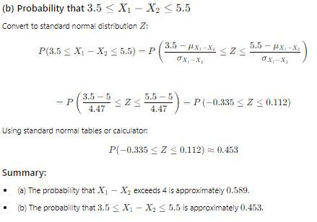
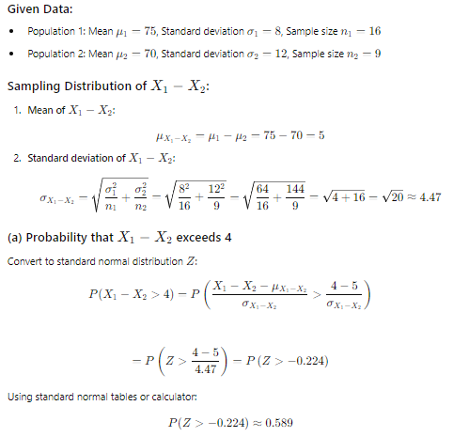

Or
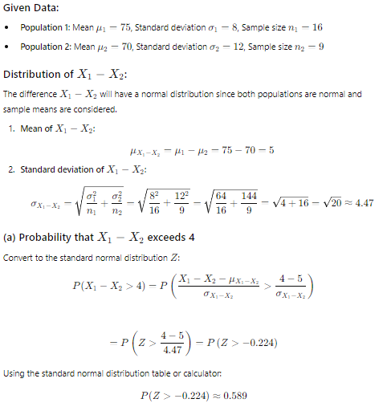
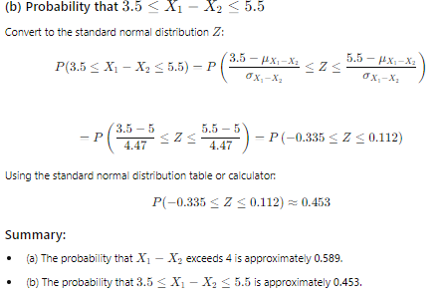

2.PVC pipe is manufactured with a mean diameter of 1.01 inch and a standard deviation of 0.003 inch. Find the probability that a random sample of 𝑛 = 9 sections of pipe will have a sample mean diameter greater than 1.009 inch and less than 1.012 inch.
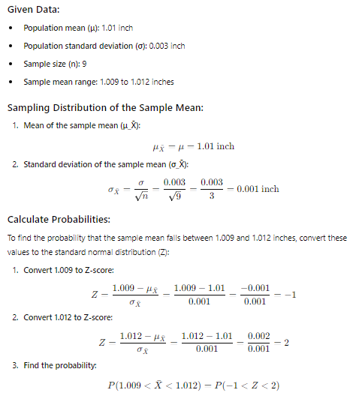
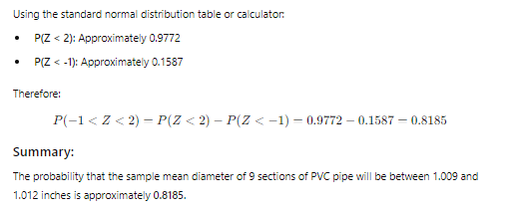
Or
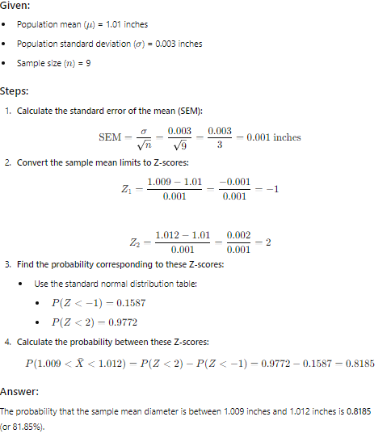

From the data on the pH of rain in Ingham County, Michigan: 5.47, 5.37, 5.38, 4.63, 5.37, 3.74, 3.71, 4.96, 4.64, 5.11, 5.65, 5.39, 4.16, 5.62, 4.57, 4.64, 5.48, 4.57, 4.57, 4.51, 4.86, 4.56, 4.61, 4.32, 3.98, 5.70, 4.15, 3.98, 5.65, 3.10, 5.04, 4.62, 4.51, 4.34, 4.16, 4.64, 5.12, 3.71, 4.64 What proportion of the samples has pH below 5.0?
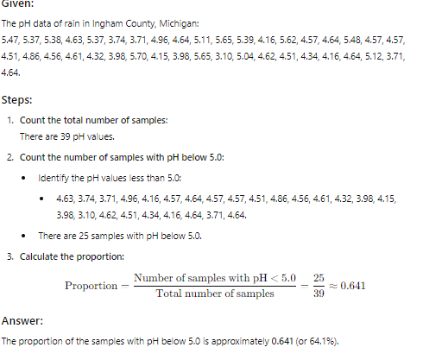

4. The following are 25 readings of proton lux in the 47-68 kEV range: 2310, 2320, 2010, 10800, 2190, 3360, 5640, 2540, 3360, 11800, 2010, 3430, 10600, 7370, 2160, 3200, 2020, 2850, 3500, 10200, 8550, 9500, 2260, 7730, 2250. (a) Find a point estimate of the mean proton flux in this time period. (b) Find a point estimate of the standard deviation of the proton flux in this time period. (c) Find an estimate of the standard error of the estimate in part (a)

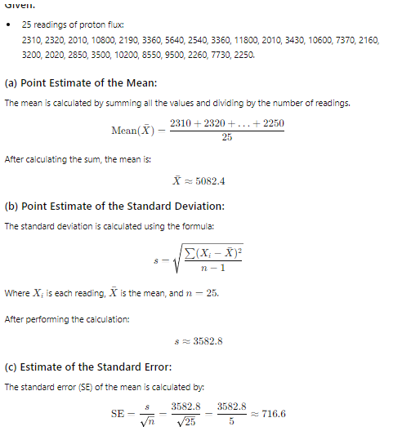
- Consider the probability density function (𝑥) = (1 + 𝜃𝑥), −1 ≤ 𝑥 ≤ 1. (a) Find the value of the constant 𝑐. (b) What is the moment estimator for 𝜃? (c) Show that 𝜃̂ = 3𝑋̅ is an unbiased estimator for 𝜃. (d) Find the maximum likelihood estimator for 𝜃
